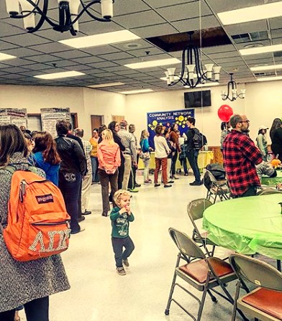
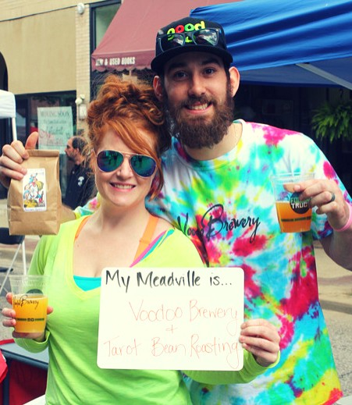
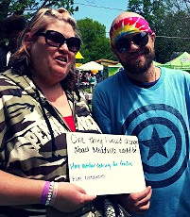
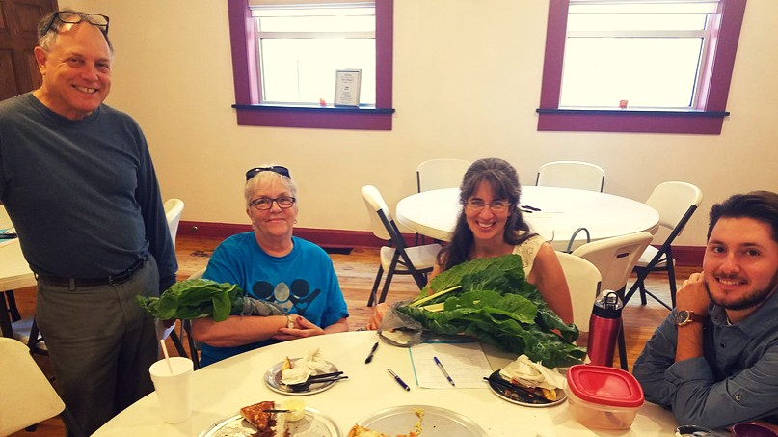
M Y M E A D V I L L E
2 0 1 7 Y E A R E N D R E P O R T
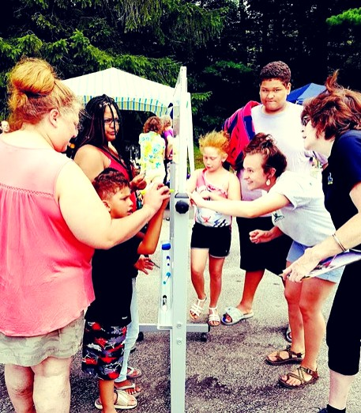
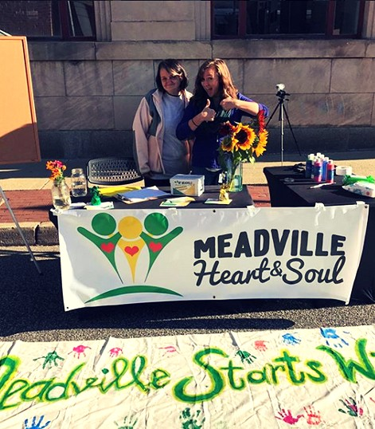

A LETTER FROM THE COORDINATOR
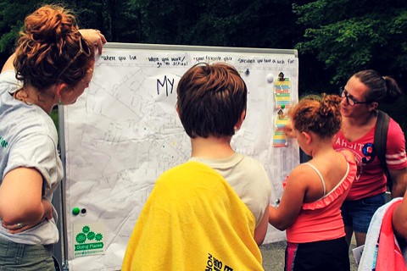
It has been a great pleasure to have been brought on this year as the My Meadville Project Coordinator. I joined the team in February of 2017 during a time of transition, but, with the help of a newly invigorated Leadership Team, we accomplished a great deal. This report will tell you more, but I'd like to take a minute to reflect on what I've come to learn as the most important part of that statement: "with the help of a... team."
This year and this work has taught me about working with people. It has taught me about understanding people's strengths and what they can bring to the
table. A process such as Heart & Soul involves constant problem-solving. Finding answers and charting a proper course involves all hands on deck, new and old. I'm proud to say we've started assembling such a crew. We have new faces in the mix with fresh ideas who have yet to hold leadership roles in our town. We have folks deeply entrenched in the the power structures of our town with decades of knowledge about the social and political dynamics at play. What keeps me going through the toughest of problems is the fact that so many people from so many corners of our town are working together to solve them. We're doing this as part of the My Meadville Heart & Soul process, but if there's anything that I hope will continue beyond the duration of the project, it's this ethos of collaborative problem-solving- that we all have something to contribute in solving the problems that face our community and that we can do so when we all have a seat at the table and are recognized as experts of our own lived experiences.

NEW ADDITIONS

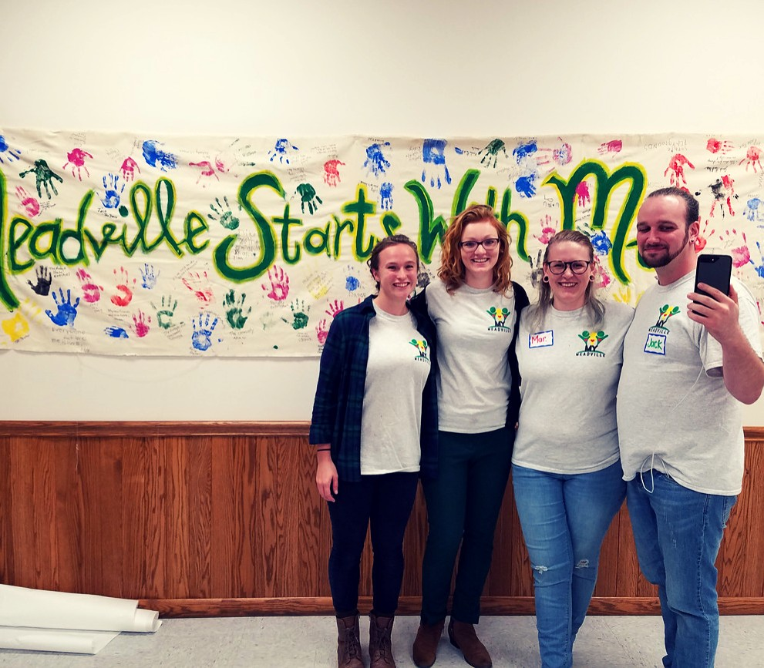
We are so fortunate to have expanded our Leadership Team in 2017. Our new Team members bring enthusiasm, new ideas, and support to the project at a time when we greatly needed it.
Welcome!

In addition, we are so thankful to have the continued dedication of our continuing Leadership Team members!
Heather Fish Zach Norwood Mar McIntire Jack Harkless Peter Zimmer Delaney Rohan
Nancy Mangilo-Bittner

Deb Lehman Stephanie Martin
Jill Withey

OUR CONNECTIONS

Over the last year, we've had the pleasure of connecting with the following organizations:

Academy Theater Active Aging
All Citizens Together Allegheny College Chanellock
CHAPS
Civic Engagement at Allegheny College Creating Landscapes for Families
Co-Op Preschool Common Roots
Communtiy Wellness Initiative Crawford County Planning Commission Crawford County Systems of Care Creating Landscapes for Families Creating Landscapes Learning Center Fairview Fairmont
Food for Thought Gill Commons Grow Meadville Market House
Meadville Area Senior High School Meadville Area Collaborative Meadville Area Recreation Complex Meadville Chamber of Commerce Meadville Children's Center
Meadville Medical Center Foundation Meadville Neighborhood Center Meadville Public Library
THANK YOU!
Meadville Redevelopment Authority Meadville Time Trade
MOMS Club of Meadville PFLAG
Rotary Club
Second Saturday Commuity Markets Showing Up for Racial Justice Thankful Thursday
Tru Grit
Unitarian Universalist Church Volunteer Income Tax Assistance

We've also connected with hundreds of Meadville residents. Here is the demographic breakdown:
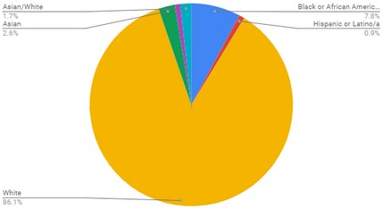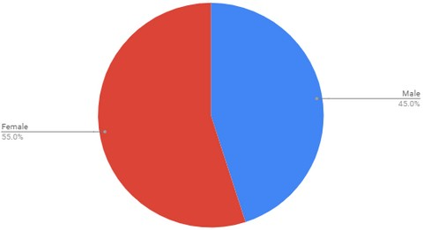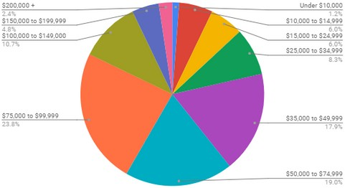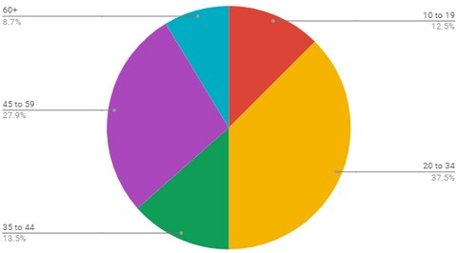
race
gender
income
age

SUMMER IN THE CITY
We spent the summer gathering stories from the people of Meadville to uncover what matters most.
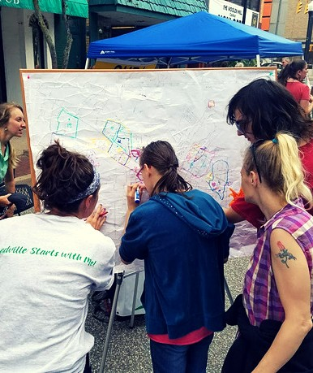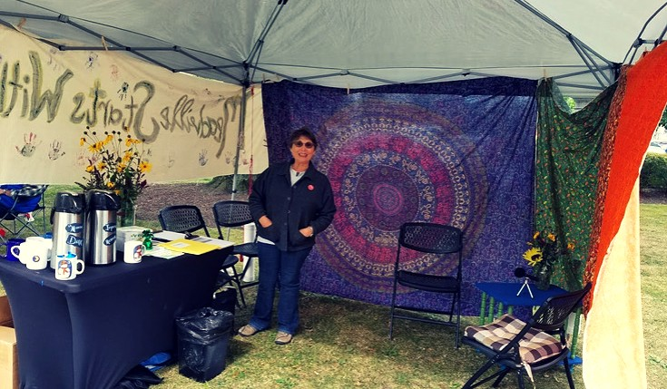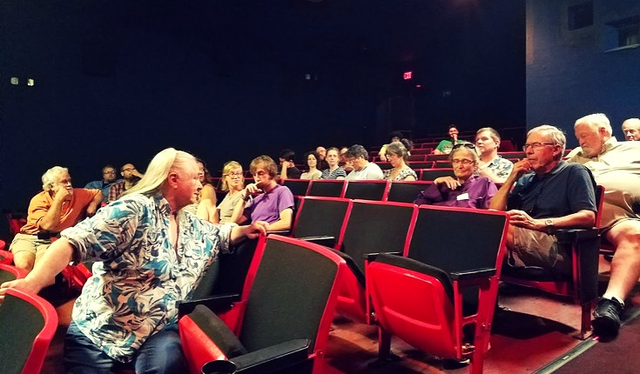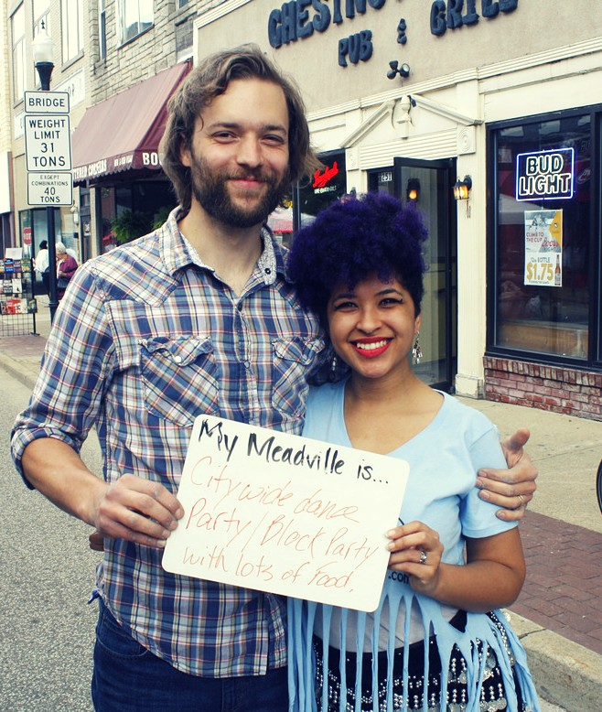
Delaney engages residents in a mapping activity at Thunder in the City.
Deb stands in our story booth inviting folks in for a cup of coffee during the Recovery Celebration at Diamond Park.
Community members engage in discussion after watching a local film about the region's economy, part of the Film 4 Thought series.
Residents share "their" Meadville at a Second Saturday Community Market.

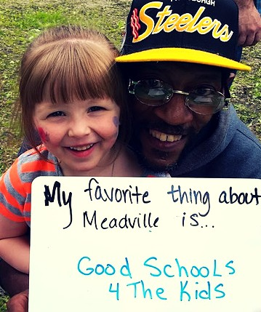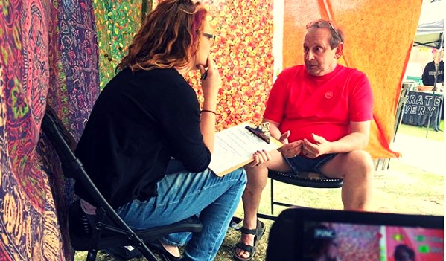
Residents share their favorite thing about Meadville at a Park Party.
We conduct one-on-one interviews like this one with Mayor Stearns.

CELEBRATING OUR COMMUNITY
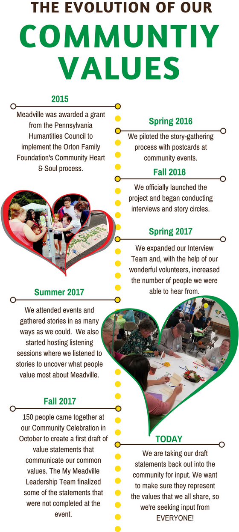
In October 2017, 150 community members converged at our Community Celebration. People came together for a wonderful meal (many thanks to all of our local restaurants who donated food!) and to delve into the data we'd collected through interviews, story cirlces, and
more. Using over 1400 data points pre-sorted into 9 themes, teams worked together to summarize what matters most to people about Meadville.
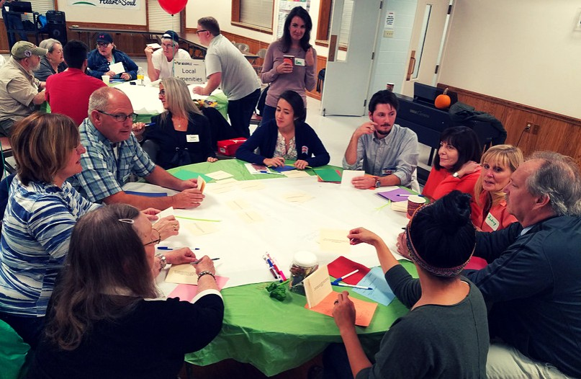
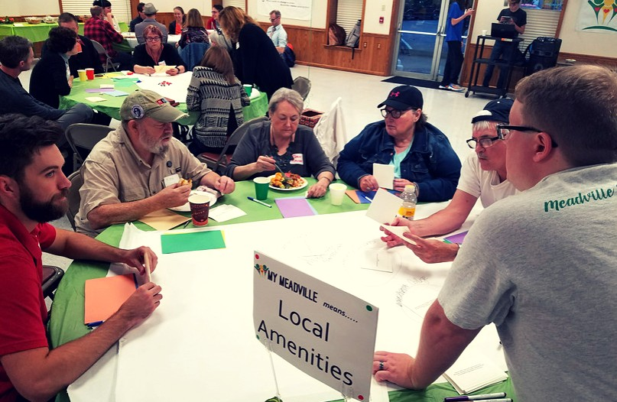
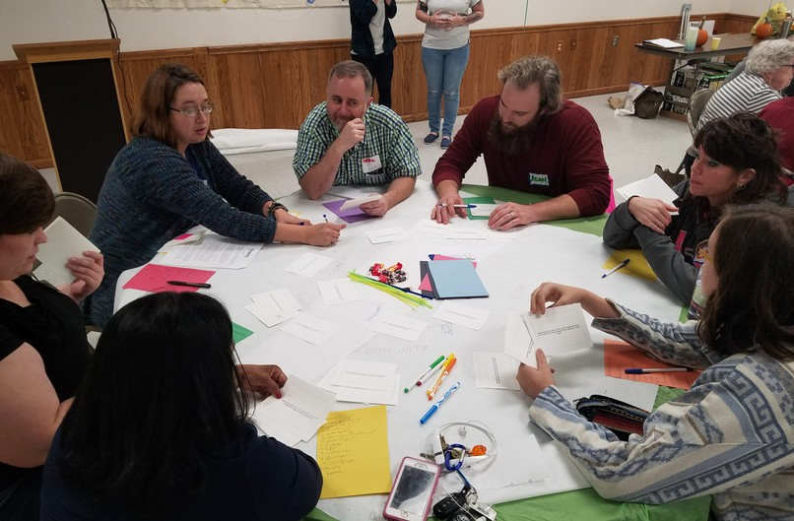
Some teams completed the task, others did not, but all were successful in helping us to make sense of the stories we gathered.

COMMUNITY THEMES & VALUES
The statements below reflect the first DRAFT of our community value statements. We are seeking feedback through spring of 2018 so that we are confidant that we have a set of statements that reflect the common values we hold for Meadville. You can weigh in at www.mymeadville.org/review
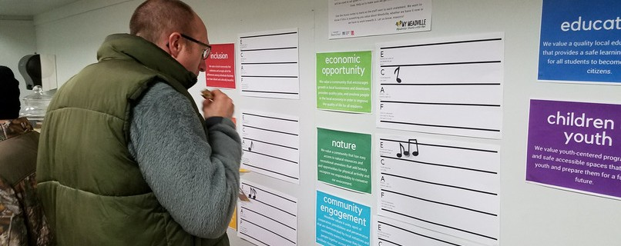
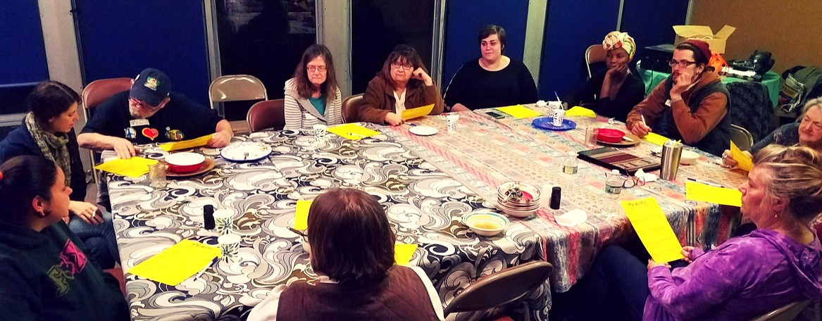

Education
We value a quality local education system that provides a safe learning environment for all students to become productive citizens.
Health & Safety
We will be a drug-free community that is aware of and has fair access to quality support services, health care, and safety networks.

Children & Youth
We value youth-centered programming and safe accessible spaces that support youth and prepare them for a fulfilling future.

Economic Opportunity
We value a community that encourages growth in local businesses and downtown, provides quality jobs, and involves people in the local economy in order to improve the quality of life for all residents.

Local Amenities
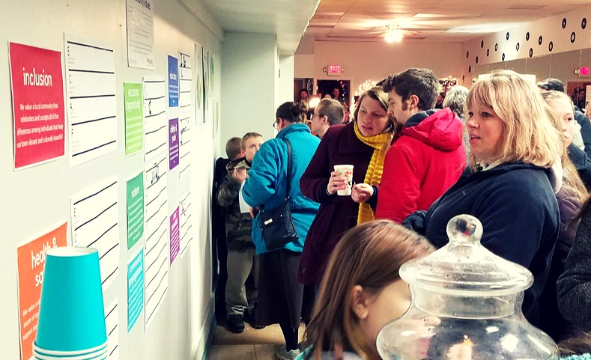
We value unique special places, businesses and events that create a sense of community identity, pride and togetherness. We also value a convenient and flexible local transportation system that makes important places accessible for all residents.
Nature
We value a community that has easy access to natural resources and recreational amenities that add beauty and opportunities for physical activity and recognize our responsibility to conserve our environment.

Community Engagement
Meadville values its unity, spirit of cooperation, possibilities and perseverance that are demonstrated by local initiatives and community events because they bring people together across difference and facilitate closeness and positive interactions.
Inclusion
We value a local community that celebrates and accepts all of the differences among individuals that keep our town vibrant and culturally beautiful.

Small Town

We value the close-knit, friendly, small-town vibe with community events, celebrations, and services which foster supportive, inclusive relationships that create a more rounded community.

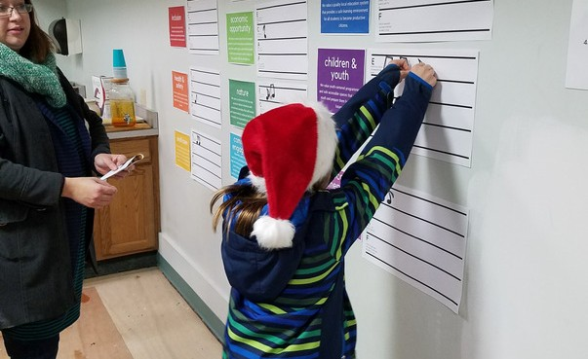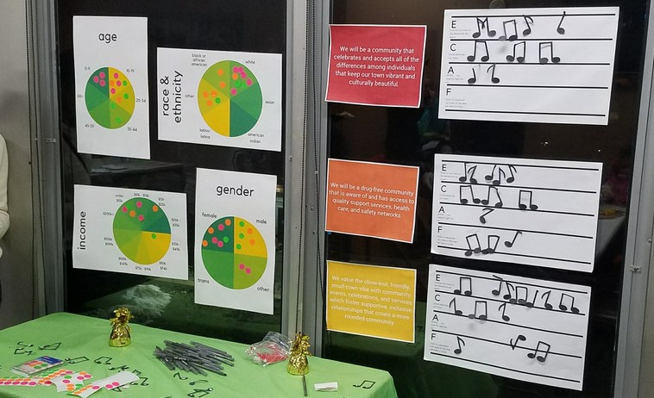

WHERE DO WE GO FROM HERE?
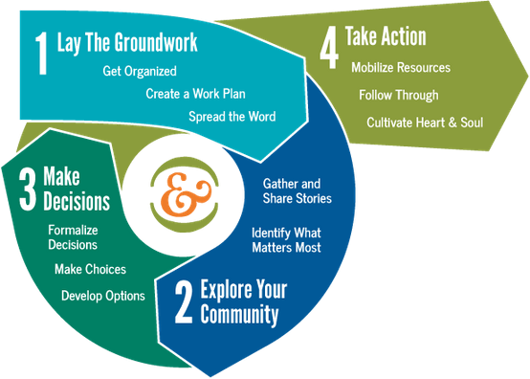
The next phase in the Heart & Soul process is Phase 3: Make Decisions. In this phase, we will develop goals and ideas for action pertaining to our value statements. These goals and action ideas will be developed with and vetted by our community and will make up a comprehensive plan for our community. A more detailed action plan will be made available in mid to late January.

If you have ideas for action, email coordinator@mymeadville.org, call 814- 337-8206 or find us on the second floor of the City Building. We'd love to hear from you!

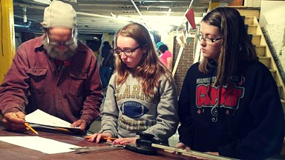
WHAT'S ALREADY UNDERWAY?
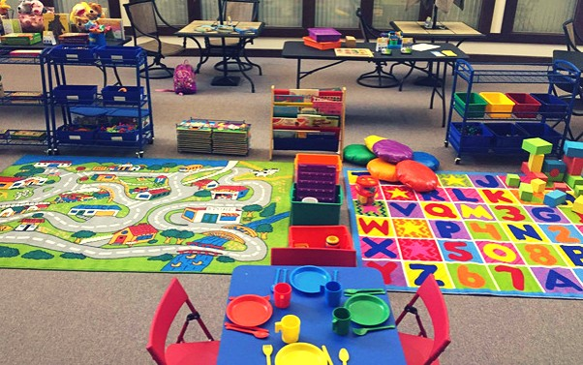
The Meadville Area Teen Lounge is in the works! We heard from so many people that Meadville's teens need a place to go. Thanks to a partnership between the Unitarian Universalist Church and the Meadville Neighborhood Center, a teen lounge is being built in the basement of the UU!

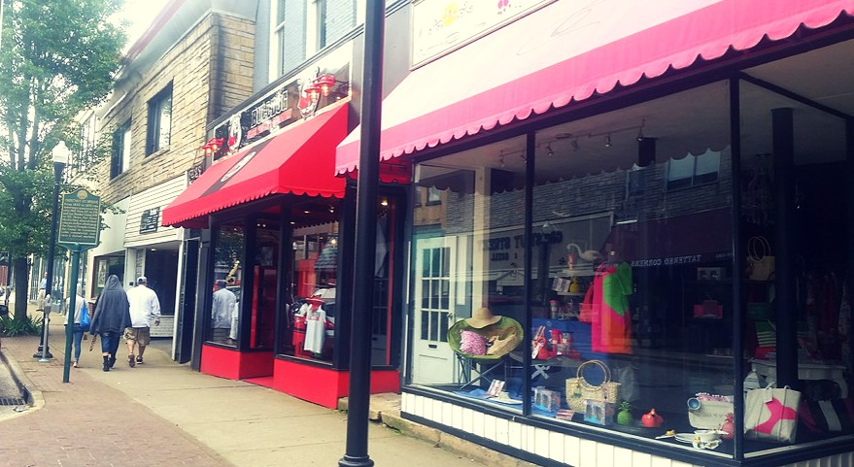
We also heard about the need for an indoor playspace for families with young children. The First Presbyterian Church of Meadville will open its doors on Tuesdays from 1pm to 3pm for families with young children to come and play. Shout out to Going Places and the Meadville Neighborhood Center for moving this forward!

In response to the feedback we got about our city's built environment, especially in our downtown, we partnered with the City of Meadville to apply for a grant to update our zoning ordinance to reflect what people want to see. The update will likely emphasize historic preservation, increase walkability, and be easy to read and understand.

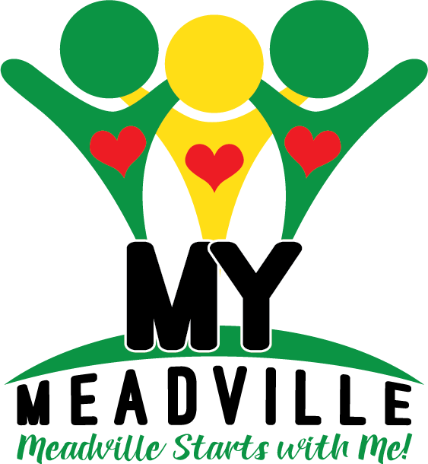

My Meadville (Meadville Heart & Soul) is supported by the Pennsylvania Humanities Council and the Orton Family Foundation Community Heart & Soul.
We are supported locally by the Redevelopment Authority of the City of Meadville.

